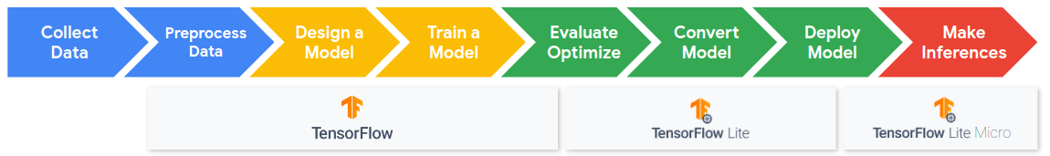

<Alt text: Machine learning workflow and pipeline. Begins with collection and preprocessing of data then the design and training of a model. These steps are done in TensorFlow. Then a model is optimized, converted and deployed using TensorFlow Lite. Finally inferences are made using TensorFlow Lite Micro.>

**What’s the Focus in this Module?**

In this section we are going to explore a very different kind of TinyML application that is showing great promise for many different application domains, **Anomaly Detection**.

**What’s New and Different?**

Anomaly Detection is different from the previous TinyML applications and datasets that we’ve explored because we are not looking to match some particular training data, or to use a particular sensor. Instead, we are focused on finding data that we explicitly have not seen before. We’ll explore what kinds of data we can use for these challenging and important applications. We’ll then explore a new paradigm of machine learning, **unsupervised learning**, that can be used to solve these problems through the use of both traditional machine learning algorithms, such as **K-Means,** and neural network based approaches, such as **autoencoders**. Finally, we’ll train one of these approaches, learn how to evaluate performance with new metrics and explore how to select a decision threshold when designing functional applications. We hope you enjoy this section!